TERMS OF REFERENCE

Air Emissions Testing and Waste/By-products Analysis of a 25-kW Waste-to-Energy Facility using a Direct Combustion Process for Municipal Solid Waste

BACKGROUND

With rapid urbanization and population growth, increase in waste generation and energy consumption have led to serious health and environmental concerns. As the country aims to have a more sustainable and environmentally benign option for solid waste management and power generation, assessment of waste-to-energy (WTE) technologies as potential technological alternative has been initiated.

The DOST GIA-funded project entitled “Establishment of a 25-kW Waste-to-Energy Facility using a Direct Combustion Process for Municipal Solid Waste” is recognized as the first WTE research venture employing direct combustion process for municipal solid waste. This project will demonstrate waste-to-energy conversion as a step in the country’s goal towards energy independence and environmental sustainability. The output of this research is targeted to serve as a basis for technology development and policy recommendations and action plans on the technical, economic, and environmental viability of a WTE system using direct combustion. With the aim to provide a science-based evaluation on the environmental impacts of WTE technologies through this research venture, evaluation of this technology in terms of its adherence to policies and regulations governing the WTE implementation in the country is an important consideration.

Hence, this project involves the assessment of a 25-kW WTE facility in terms of its compliance with air emission standards pursuant to Republic Act 8749 or the Philippine Clean Air Act. Likewise, hazardous waste and effluent characteristics of the facility will also be evaluated as stipulated in Republic Act 6969 (Toxic Substances and Hazardous and 26 Nuclear Wastes Act) and Republic Act 9275 (Philippine Clean Water Act), respectively.

- BASIC INFORMATION OF THE PROJECT

  - Site: Waste-to-Energy Facility located at the UPLB Transloading Area (formerly known as the WARM facility), UP Los Baños, College, Laguna

  - Type of Service: Assessment of a 25-kW Waste-to-Energy Facility using a Direct Combustion Process for Municipal Solid Waste in terms of air emissions and waste/by-products analysis

  - ABC for this consultancy service: Php 1,520,038.19

- PROJECT TIMETABLE

TIME FRAME. The period for the CONSULTANT’s services is expected to be 30 Calendar Days inclusive of final report submission.

- CONSULTANT QUALIFICATION

  - The CONSULTANT shall be a firm/company providing AIR EMISSIONS TESTING AND WASTE ANALYSIS services, duly registered with the Security and Exchange Commission (SEC) or the Department of Trade and Industry (DTI), owned and managed by professionals qualified and duly licensed to undertake work in TESTING, INSPECTION, and CERTIFICATION.

  - The CONSULTANT shall have demonstrated competence for projects of similar complexity, use and character. The CONSULTANT shall show previous experience undertaking work in AIR EMISSIONS TESTING AND WASTE ANALYSIS.

The Bidder shall indicate in his technical proposal, a description of completed and ongoing projects, citing features and merits of particular projects where the above-mentioned requirements have been fulfilled.

  - The CONSULTANT must be operational for at least eight (8) years and shall have proven capacity to complete the project and provide the appropriate experts and project staffing.

- MANPOWER AND QUALIFICATION REQUIREMENTS

The CONSULTANT shall provide the manpower requirements upon the effectivity of the contract with the following qualifications and functions:

  - The CONSULTANT manpower requirement shall include the following:

TABLE 1. PROJECT KEY PERSONNEL
Position | Responsibilities | Qualifications
Quality Assurance/Quality Control Manager | Project management - leads in the Consulting team in maintaining quality control processes, procedures, and efficiency standards | Duly licensed/registered engineer
Team Leader | Project coordination – coordinates the work of project personnel; coordinates production of reports and other outputs; coordinates the project schedules and requirements with the UPLB in behalf of the Consultant. | Graduate of any degree in related field;  Proven work experience as a team leader or supervisor
* To be named in the Bidder’s Proposal
* Curriculum Vitae shall be submitted as proof for qualifications.

  - The CONSULTANT may assign other support personnel in addition to those listed, for the optimal performance of the work/service at no additional cost to UPLB.

- SCOPE OF SERVICES

  - General Scope of Work

The CONSULTANT shall be responsible for carrying out the necessary works on air emissions testing and waste/by-products analysis in respect to the project stated.

The CONSULTANT shall properly coordinate with UPLB on the project’s site location, timeline, etc. and shall be required to submit an approved site inspection certificate from UPLB.

Upon completion of the air emissions testing and waste/by-products analysis work activities, the CONSULTANT shall submit their final report containing the assessment of air emissions quality and waste/by-products analysis to UPLB.

The CONSULTANT shall be responsible for the reliability of the report presented.

  - Detailed Scope of Work

The CONSULTANT shall provide all the labor, instrument/equipment materials and supplies, vehicles, etc., necessary to perform satisfactorily the air emissions testing and waste/by-products analysis herein required, namely:

- Ash Analysis
- Conduct ash analysis for two (2) samples of the WTE facility.
- Sample size: Minimum of 1 kg/sample
- Collection of samples from identified source/s using appropriate methodology specified for ash analysis
- Transportation of samples to service laboratory for analysis
- Analysis of samples for the parameters specified as follows:

Parameters for analysis:
a. AAS/ICP Methodology: Ag, Ca, Cd, Co, Cr, Cu, Fe, K, Mn, Mg, Na, Ni, Pb, Sb, Zn, Al, Ba, Si, Sn, Ti, Hg, As, Se
b. USEPA M1613B Methodology: Dioxins and Furans
c. Sludge Characterization: pH, Moisture, Toxicity, Ignitability, Corrosivity

- Includes Sampling, Sample Preparation (USEPA Method 1311), Courier and Mobilization Fees

- Stack gas and ambient air sampling and analysis
- Conduct source emission testing and ambient air monitoring of the WTE Facility
- Collection of samples from identified source/s using methodology (US EPA Methods for Source Measurement) for stack gas sampling and ambient air
- Transportation of samples to service laboratory for analysis
- Analysis of samples for the parameters specified as follows:

Parameters for Stack Emission Testing (1 sample only - 3 runs per parameter):
a. Total Suspended Particulates
b. Nitrogen Dioxide (NO2)
c. Sulfur Dioxide (SO2)
d. Carbon Monoxide (CO)
e. Dioxins and Furans (4 sampling points)

Parameters for Ambient Air Monitoring:
a. Upwind: PM10, SO2, NO2 (1 sample only - 3 runs per parameter)
b. Downwind: PM10, SO2, NO2 (2 samples only - 3 runs per parameter)

- Provision of additional source data information in compliance to DENR Administrative Order (DAO) 2000-81 guidelines on the issuance of Permit to Operate

- Proximate Analysis of Fuel

Municipal Solid Waste (MSW) sample will be accurately analyzed for the following parameters:
- Moisture
- Volatile Combustible Materials
- Ash
- Fixed Carbon

Number of samples: 5 (Five)

- Ultimate Analysis of Fuel

Municipal Solid Waste (MSW) sample will be accurately analyzed for the following parameters:

- Carbon
- Hydrogen
- Chlorine
- Oxygen (as calculated)
- Nitrogen
- Ash
- Sulfur

Number of samples: 2 (Two)

- Water Analysis

Water sample will be accurately analyzed for the following parameters:

- Total Dissolved Solids
- Total Suspended Solids
- Total Hardness

Number of samples: 25 (Twenty-five)

- REPORT OUTPUT/DELIVERABLES

- Final Report

The CONSULTANT shall prepare the FINAL REPORT containing results of air emissions analysis and waste/by-products characterization in respect to the project stated in the form and substance to be submitted to UPLB, Thirty (30) Calendar Days from the commencement of work. The final report shall include, but not be limited to the following:

  - Concise description of methodology used for analysis
  - Final laboratory test results on ash analysis, stack gas and ambient air sampling and analysis, proximate and ultimate analysis of fuel, and water analysis

- INTELLECTUAL PROPERTY AND CONFIDENTIALITY OF DATA

The ownership of all intellectual property, including any test results and reports generated by the CONSULTANT in the performance of the services subject of this Agreement shall vest solely with UPLB.

The CONSULTANT undertakes to keep confidential all information that it has received from UPLB, as well as all results, data and reports that it will generate. It shall protect such information and ensure that it shall be handled in such a way that no unauthorized disclosure shall be made.

Upon the termination of the CONSULTANT’s services, all data, records and materials shall be turned over to UPLB. Any materials or records that cannot be turned over shall be destroyed, erased or formatted to ensure that no records remain in the possession of the CONSULTANT.

- WARRANTIES OF THE CONSULTANT

  - The CONSULTANT warrants that it shall conform strictly with the terms and conditions of these Terms of Conditions.

  - The CONSULTANT warrants, represents and undertakes reliability of the service required to the satisfaction of UPLB. It shall employ highly skilled, well behaved, and honest employee with ID displayed conspicuously while working within the compound. It shall not employ UPLB employees to work in any category.

  - The CONSULTANT’s personnel shall take all necessary precautions for the safety of all persons and properties at or near their area of work and shall comply with all the standards and established safety regulations, rules, and practices.

  - The CONSULTANT shall coordinate with any authorized and/or designated UPLB personnel in the performance of their jobs. There shall be no employer-employee relationship between the CONSULTANT and UPLB.

  - The CONSULTANT shall be liable for loss, damage or injury as may be due directly through the fault or negligence of its personnel. It shall assume responsibility thereof and the UPLB shall be specifically released from any responsibility arising therefrom.

  - The CONSULTANT shall comply with all documents that are related to this project that may be required by the Commission on Audit even after completion of the project at no additional cost to the UPLB.

  - The CONSULTANT shall neither assign, transfer, pledge, nor subcontract any part or interest therein.

The Terms of Reference for the Air Emissions Testing and Waste/By-products Analysis of a 25-kW Waste-to-Energy Facility using a Direct Combustion Process for Municipal Solid Waste is hereby:

Prepared by:

Dr. Manolito E. Bambase, Jr.
Project Leader and Associate Professor

ANNEX A
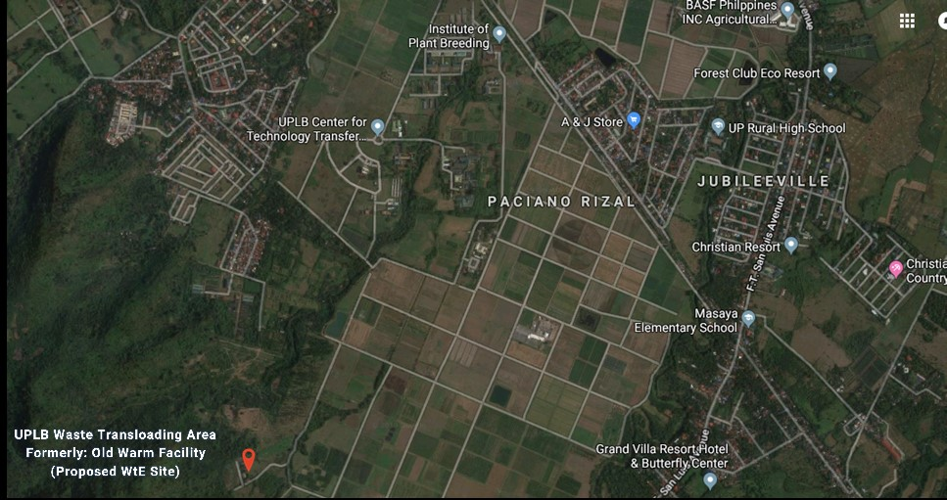
PROPOSED SITE LOCATION
EE Building Phase II

